Givi Download and Log-In Instructions

You can search for and download the Givi app in your device’s App store (App Store for iPhone users and Google Play Store for Android users).
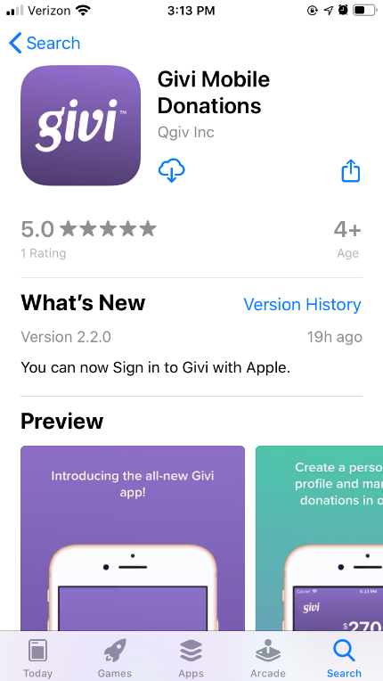
When you open the app after downloading, you’ll land on a login screen with several options.
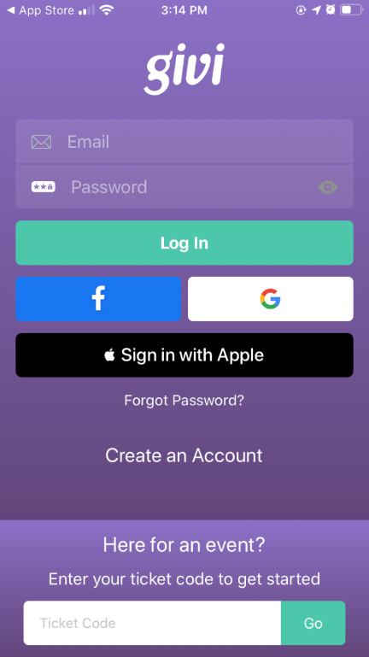
For first-time users, select Create an Account on the home screen to open the account creation page.
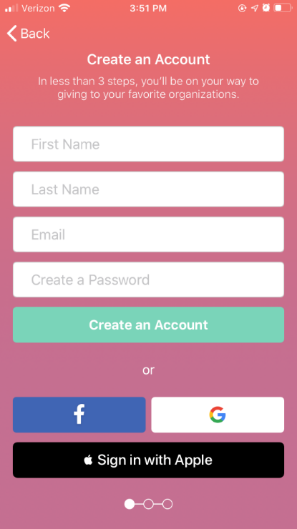
There are several options you can use to create your account. You can simply fill in the First Name, Last Name, Email, and Password fields to create an account, or you can create an account linked to your Facebook, Google, or Apple accounts (the last option isn’t available on non-Apple devices).
Option 1: Create a Givi account using an email and password
Fill in the fields and click the Create an Account button. Once you’ve entered your information in the fields and clicked the Create an Account button, you’ll be taken to the next step of account creation, which is the option to enter payment Information. You can choose to enter a payment method during signup or add a payment method later.
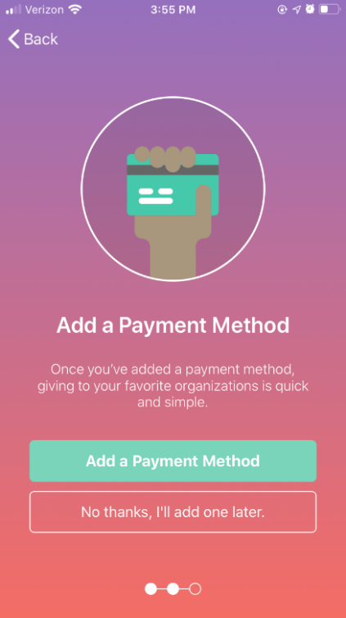
If you elect to add a payment method, you’ll be taken to a screen to enter those details. Your choices of payment method are credit card or eCheck.
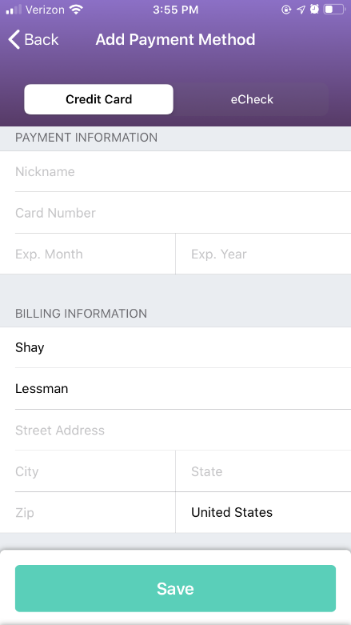
Once you’ve completed filling in your payment information click the save button to complete account creation. Click the take me home button to enter the app with your new Givi account!
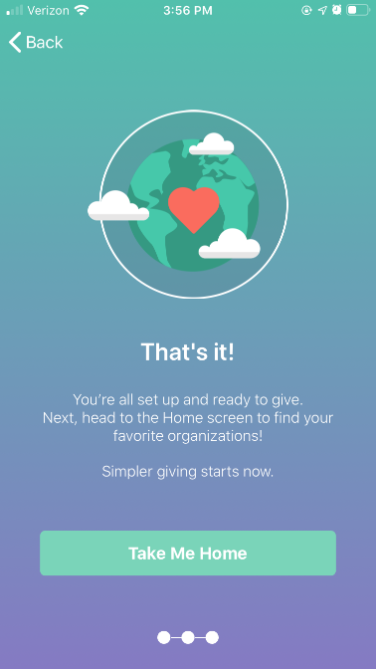

Option 2: Create a Givi account with Facebook
If you want to link your Givi account to Facebook, click the Facebook button on the Create An Account Screen. A pop-up window will appear confirming your intent is to create an account with Facebook. Click Continue to confirm.
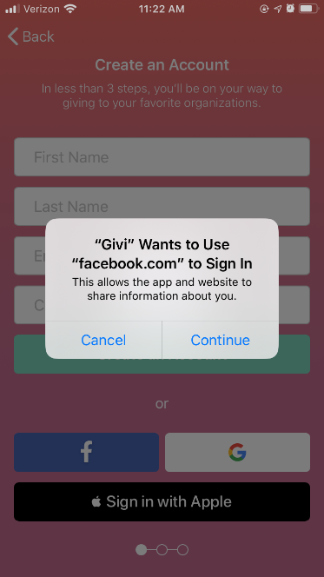
Next, you’ll be taken to the Log in With Facebook screen. You must either enter your Facebook account credentials if you aren’t already logged in or select Continue as “Name” to create an account based on information Givi receives from your Facebook profile. Note that we require the app to collect your name and profile picture. Providing your email address is optional. If you needed to enter log-in credentials, click log in to reach the page where you can review the data sent to Givi for account creation.
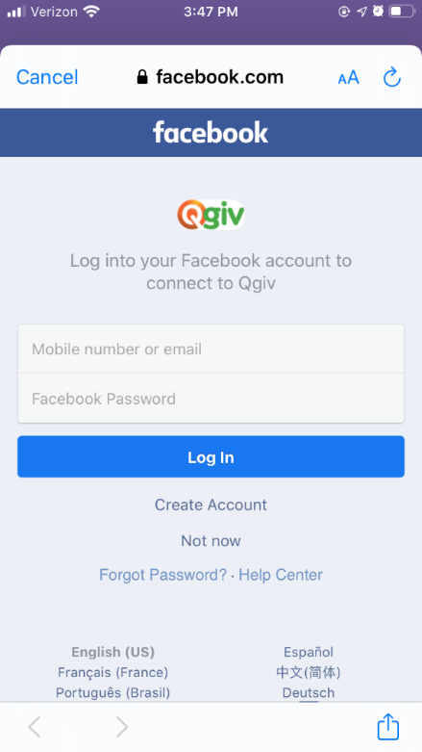
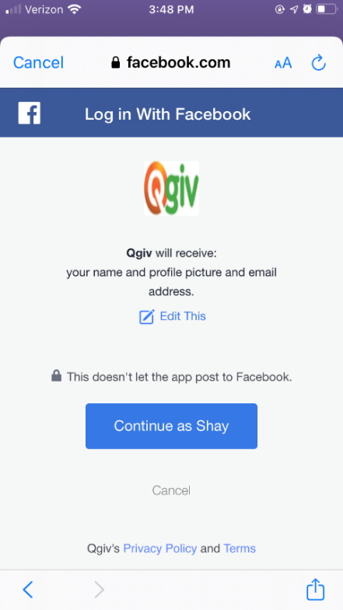
If you’ve enabled two-factor authentication for your Facebook account you may be prompted to enter a code from an authenticator app to complete signup.
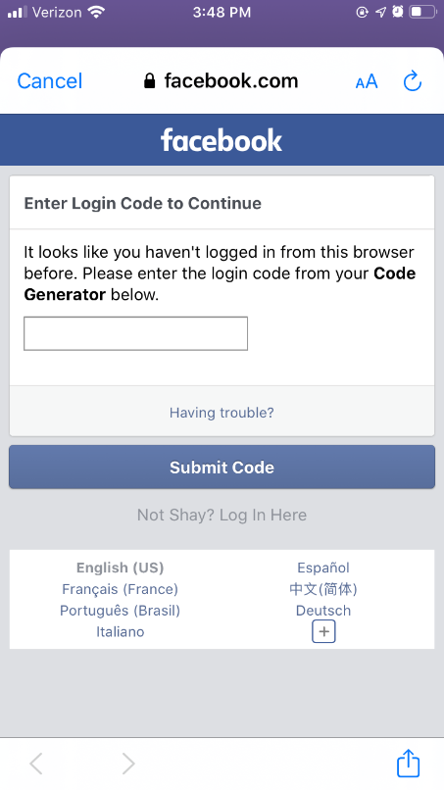
If you don’t use a code generator for two-factor authentication, click the “Having Trouble?” link for additional ways to authenticate your Facebook account.
Once you’ve entered your code click Submit Code to finish linking Givi to your Facebook account. Next, you’ll be given the option to enter payment information or proceed to finalize account creation.
Option 3: Create a Givi account with Google To create an account using an existing Google account click the Google button on the Create a New Account screen. A pop-up window will appear asking you to confirm your intention to link a new Givi account to your Google account. Click continue to proceed to account creation.
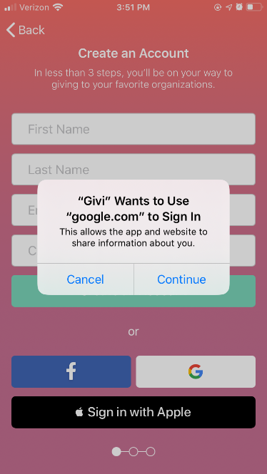
Next, you’ll need to select your Google account from a list of Google accounts associated with your device. Then, on the next screen you’ll be prompted to enter the password of your Google account.
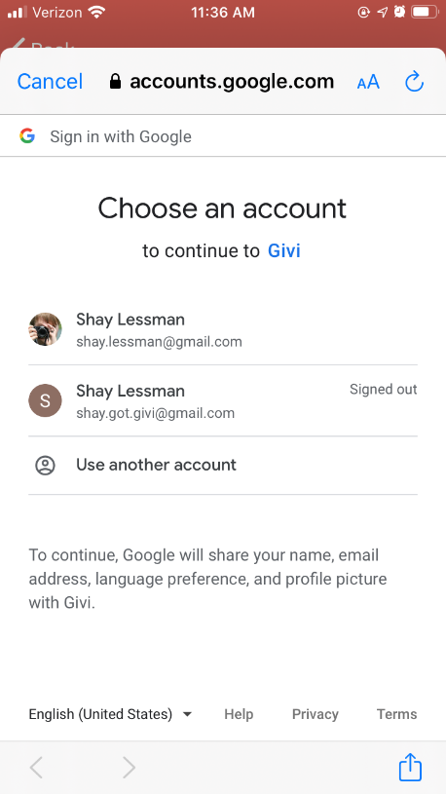
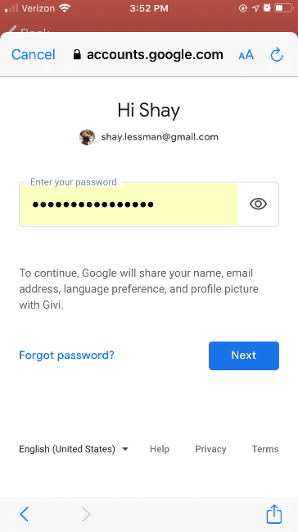
If none of the listed accounts are the one you intend to use, select “Use another account” to manually enter Google account credentials for an unlisted account or create a new Google account for Givi.
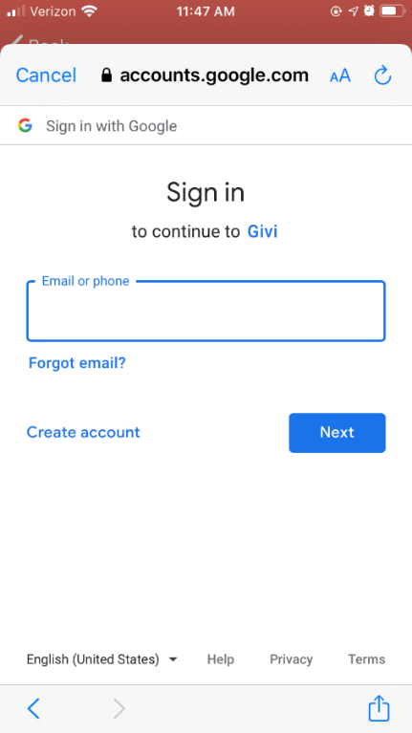
Once you’ve created or signed in to your Google account, you’ll proceed to the optional payment method entry step. Choose to enter payment method information during signup or skip to the last step to finalize account creation.

Option 4: Creating a Givi account with Apple
The final option for creating your account is exclusive to Apple device users. Select Sign in with Apple to create a Givi account linked to your Apple ID.
If you use your fingerprint to secure your Apple account, you’ll be prompted to use your fingerprint to verify you are the one creating the Givi account.
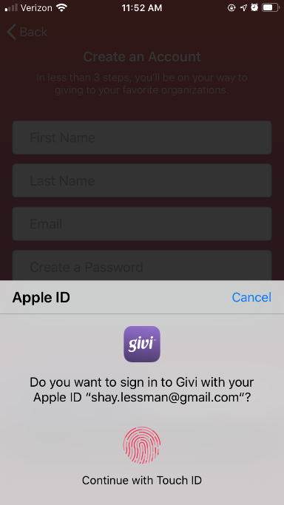
If you don’t use Touch ID on your Apple device, you’ll be prompted to enter your account password. Enter the password then click Continue.
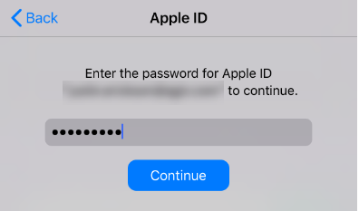
Next, your account will be created and tied to your Apple ID. You’ll then proceed to the option to enter a payment method or skip to the last step and finalize Givi account creation.
Once you’ve created an account using any of the methods above, you’ll be able to log in to your account using the sign in method that corresponds to the account creation method you used.

