**Givi Download and Login Instructions**

You can search for and download the Givi app in your device’s app store (App Store for iPhone users and Google Play Store for Android users).

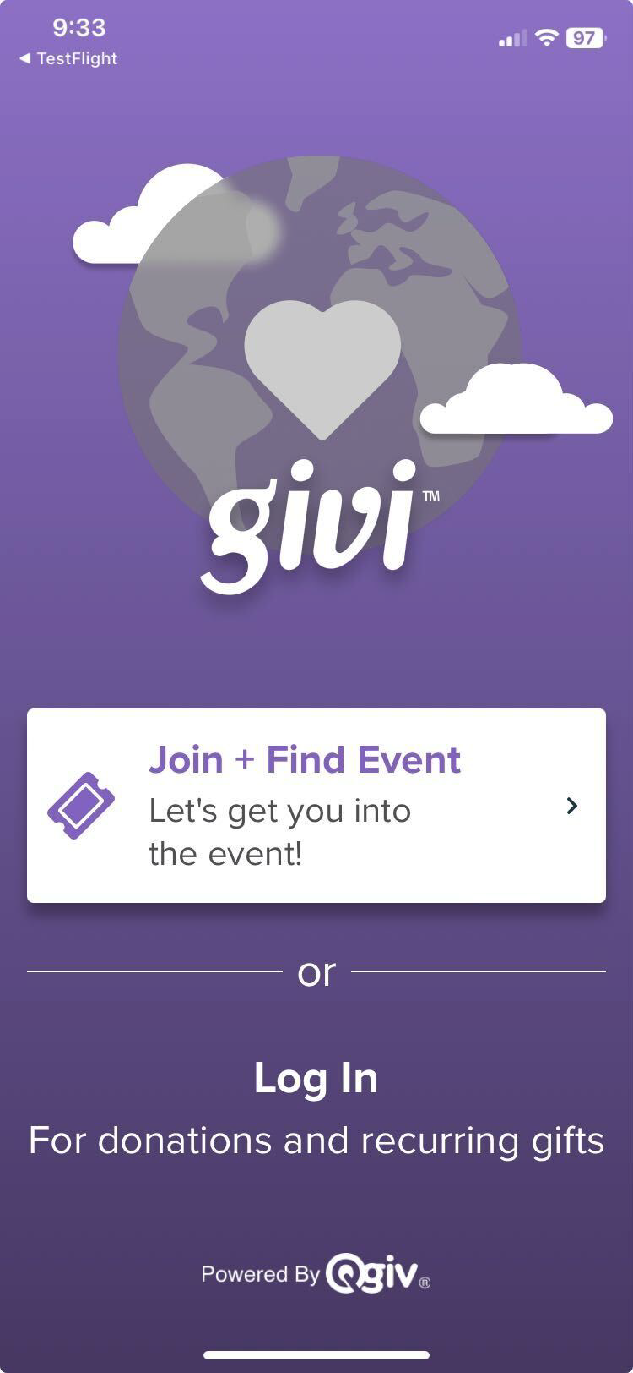

When you open the app after downloading, you’ll land on a screen with several options. If you’d like to access an auction, click **Join + Find Event**. You’ll be prompted to enter your email address to join an auction you’ve already registered for or search for an auction you’d like to register for.

If you’d like to create a Givi account to easily donate to your favorite nonprofit, click **Log In** and then select **Create an Account** to open the account creation page.

There are several options you can use to create your account. You can simply fill in the First Name, Last Name, Email, and Password fields to create an account, or you can create an account linked to your Facebook, Google, or Apple accounts (the last option isn’t available on non-Apple devices).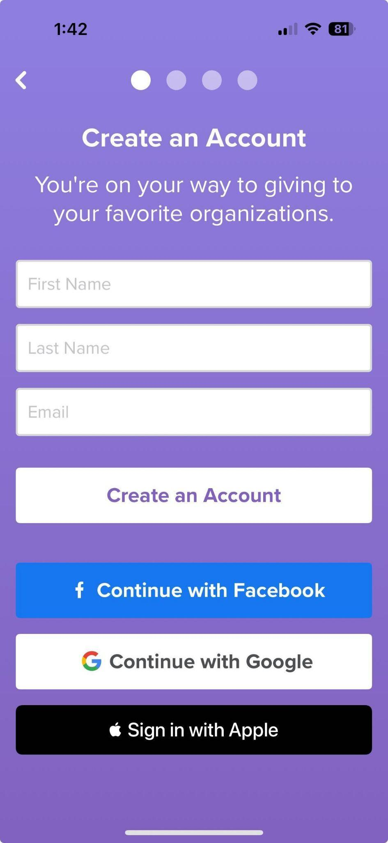

Once you’ve created an account using any of the following methods, you’ll be able to log in to your account using the corresponding service.

**Option 1: Create a Givi account using an email and password**

Fill in the fields and click the **Create an Account** button. You’ll be taken to the next step of account creation, which is to verify your identity. 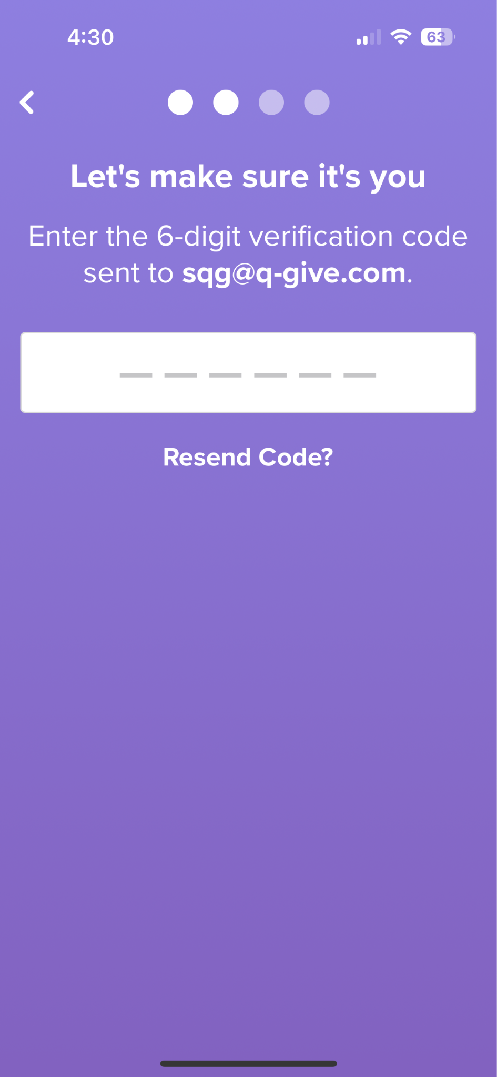

A 6-digit code will be emailed to the address you entered. Input the code to verify your email address.

You’ll be prompted to create a password to finish setting up your account. Click **Submit** when you’re ready.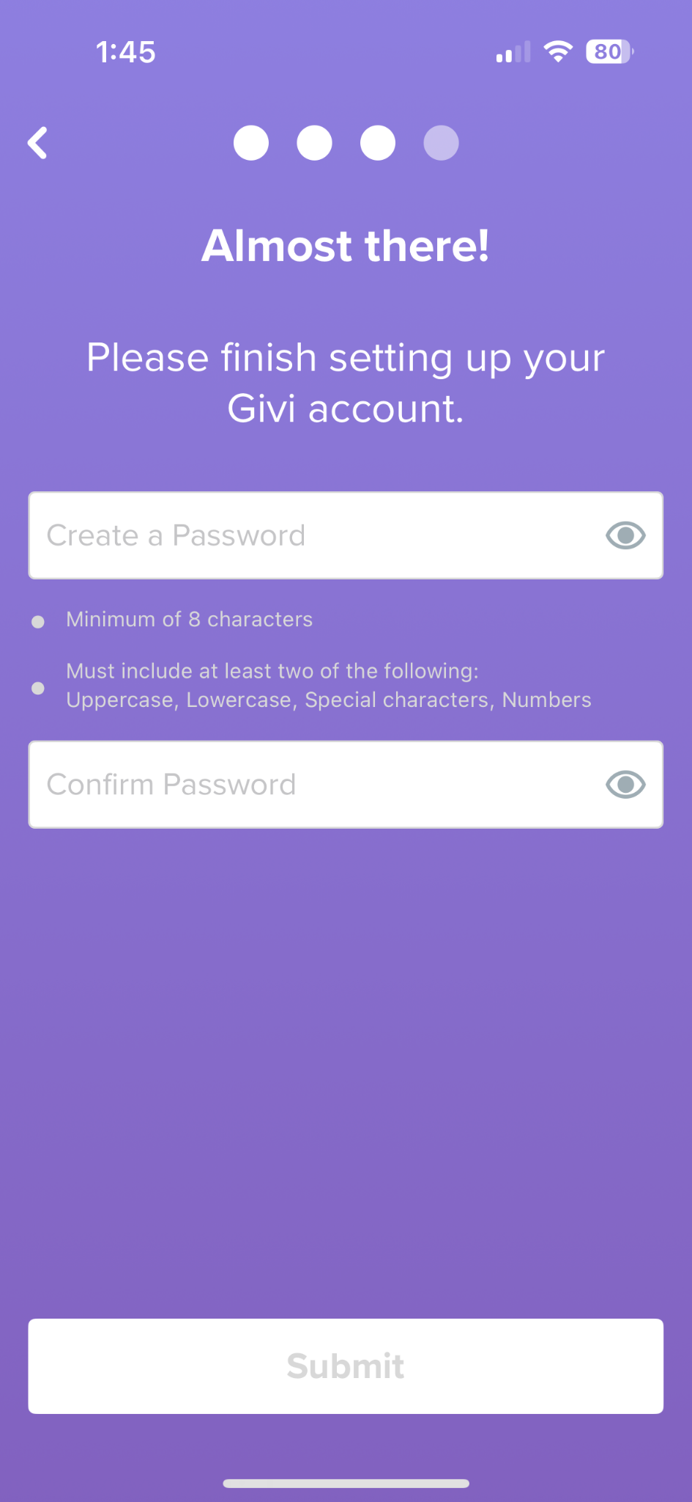

Next, you’ll see the option to enter payment information. You can choose to enter a payment method during sign-up or add a payment method later.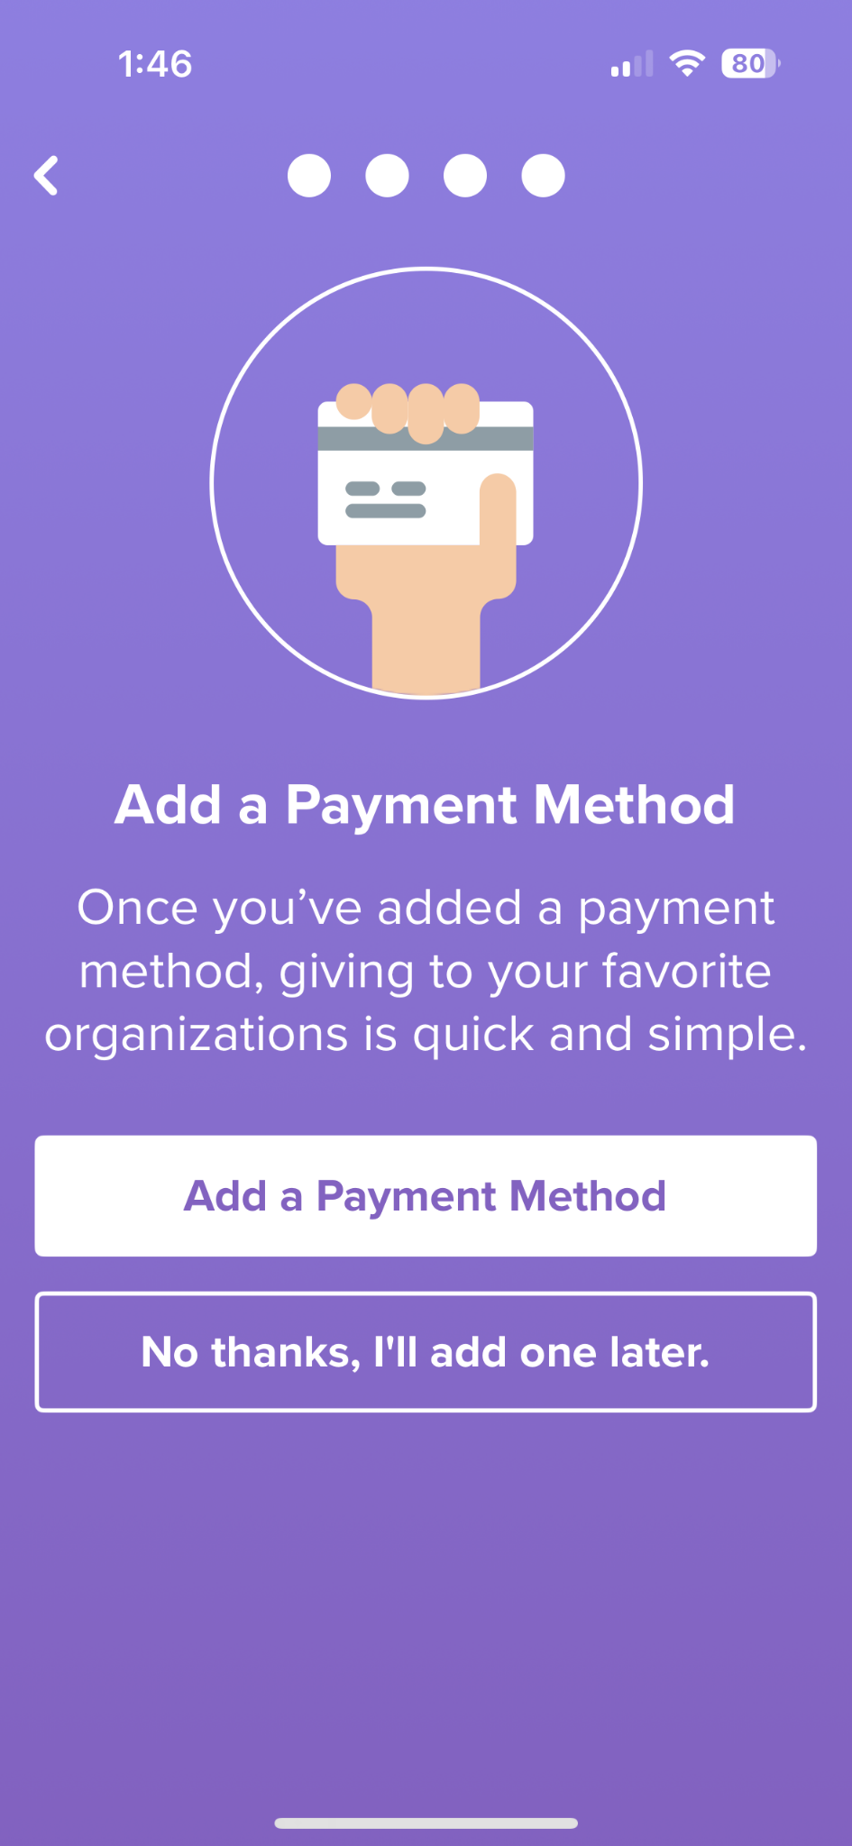

If you elect to add a payment method, you’ll be taken to a screen to enter those details. Your choices of payment method are credit card or eCheck.

Once you’ve added your payment information, click the save button to complete account creation. Click the **Take Me Home** button to enter the app with your new Givi account!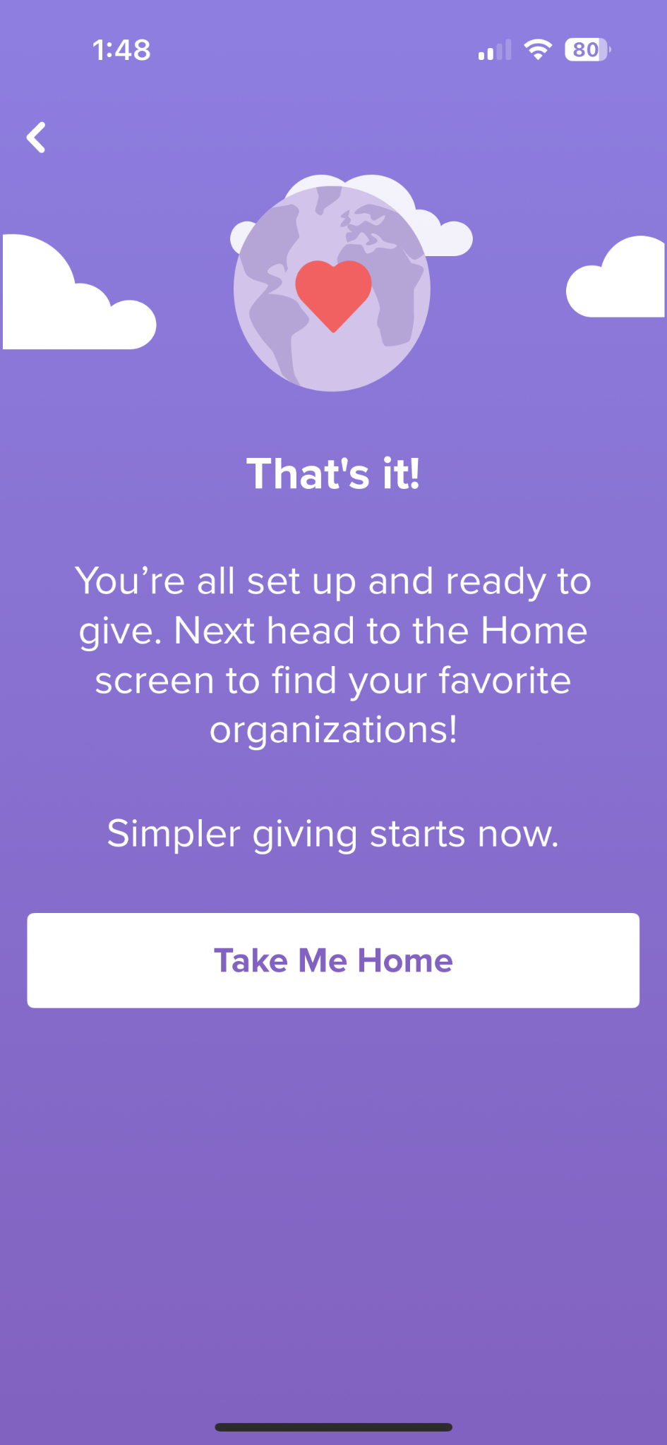

**Option 2: Create a Givi account with Facebook**

If you want to link your Givi account to Facebook, click the **Continue with Facebook** button on the Create An Account Screen.

A pop-up window will appear confirming your intent is to create an account with Facebook. Click **Continue** to confirm.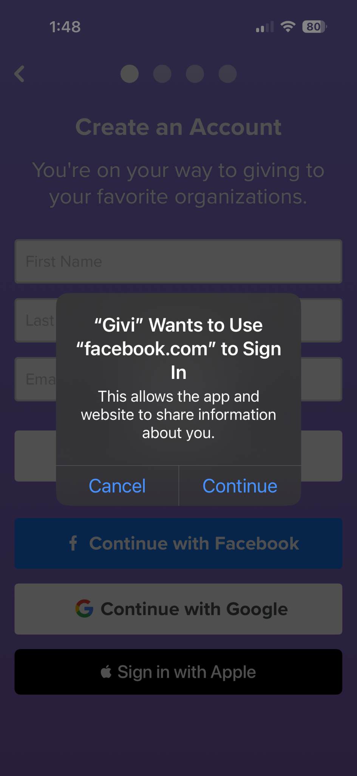

Next, you’ll be taken to the Facebook login screen. You must either enter your Facebook account credentials if you aren’t already logged in or select **Continue as [Name]** to create an account based on information Givi receives from your Facebook profile. 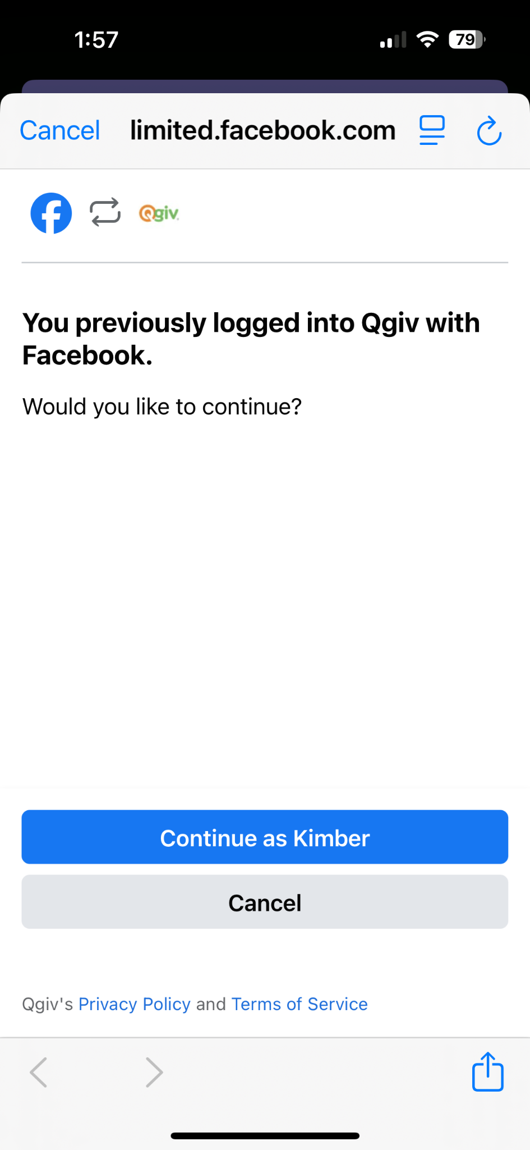

Note that we require the app to collect your name and profile picture. Providing your email address is optional. If you need to enter login credentials, click log in to reach the page where you can review the data sent to Givi for account creation.

If you’ve enabled two-factor authentication for your Facebook account you may be prompted to enter a code from an authenticator app to complete sign-up.

If you don’t use a code generator for two-factor authentication, click the “Having Trouble?” link for additional ways to authenticate your Facebook account.

Once you’ve entered your code click Submit Code to finish linking Givi to your Facebook account. Next, you’ll be given the option to enter payment information or proceed to finalize account creation.

**Option 3: Create a Givi account with Google**

To create an account using an existing Google account, click the **Continue with Google** button on the Create a New Account screen. 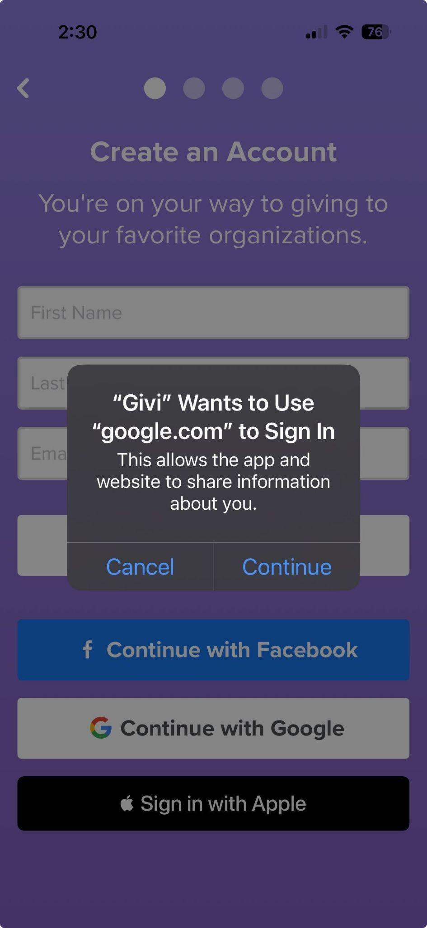

A pop-up window will appear asking you to confirm your intention to link a new Givi account to your Google account. Click **Continue** to proceed to account creation.

You’ll be prompted to log in to your Google account or select it from a list of accounts associated with your device.

Once you’ve created or signed in to your Google account, you’ll proceed to the optional payment method entry step. Choose to enter payment method information during sign-up or skip to the last step to finalize account creation.

**Option 4: Creating a Givi account with Apple**

The final option for creating your account is exclusive to Apple device users. Select **Sign in with Apple** to create a Givi account linked to your Apple ID.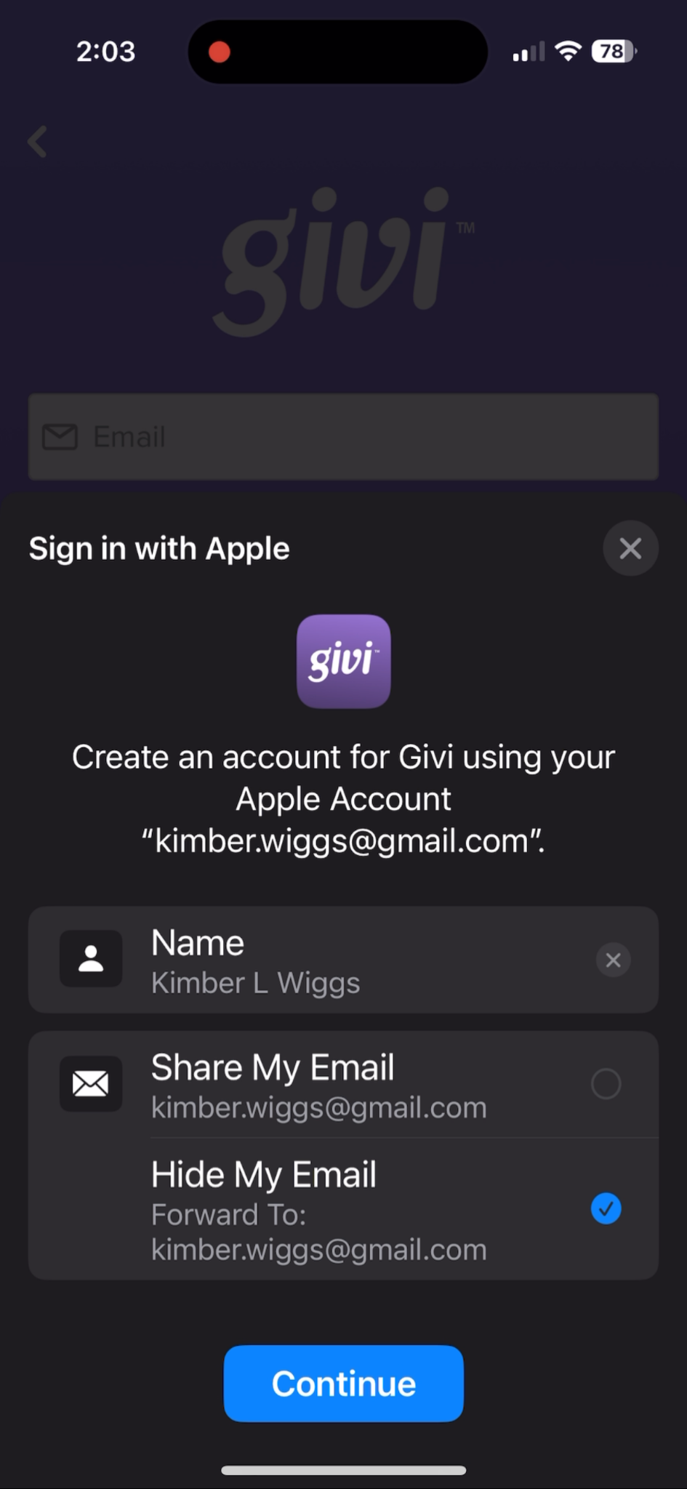

You can choose to Share or Hide your email address from the app. Then, tap **Continue**.

***Please note:*** If you choose to hide your email address, you’ll be logged in to Givi anonymously, which means we won’t be able to link event tickets to your Givi account. If you’re using Givi to participate in an auction, we recommend you share your email address when creating your account.

Your account will be created and tied to your Apple ID. You’ll then proceed to the option to enter a payment method or skip to the last step and finalize Givi account creation.