This editable Word document is designed to let you customize the guide for your registration. All notes in red should be replaced or deleted prior to sharing with constituents. Feel free to remove any instructions that are not relevant to your event. For example, if you’ve disabled classifications, simply remove that section of this guide.

We’ve also made recommendations for images you may want to replace with screenshots from your own event to match your event’s branding. If you prefer to use the images included in this document, simply delete the “[replace image]” notes.

Peer-to-Peer Participant Registration Guide

This guide will walk you through the registration process for [enter your event’s name here].

Click here to get started: [insert link to your peer-to-peer site].

First, click the **Register** link on the event site.

[replace image with a screenshot of your Register button]



To start, you’ll need to select how you’ll be participating in the event.

First, select your **Classification** [if you’ve changed the Classifications label, replace this with the wording you chose]. Make your selection, and then click **Next**.

[replace image with a screenshot of your Classifications page]

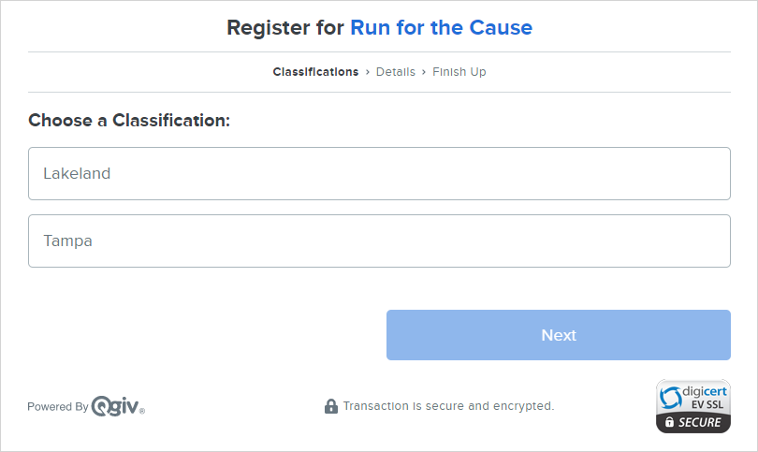

Next, you’ll decide **how you want to participate**. [If you’ve opted for a Single Category registration, registrants will skip this screen. Remove it from the guide.]

[replace image with a screenshot of your Categories page]

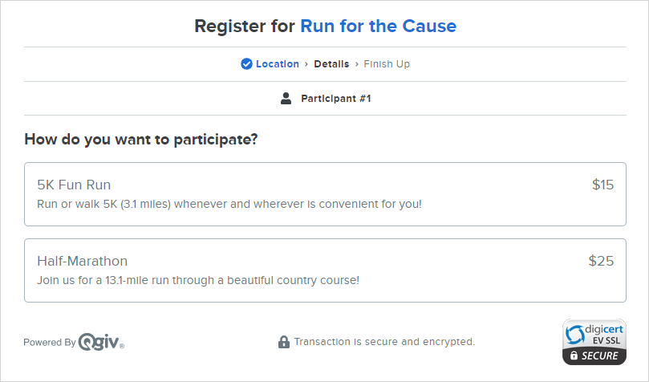

After that, decide if you’ll be participating **As an Individual** or if you want to **Join or Create a Team**. [If you’ve disabled team registrations, remove this section.]

[replace image with a screenshot of your Individual vs. Teams selection]

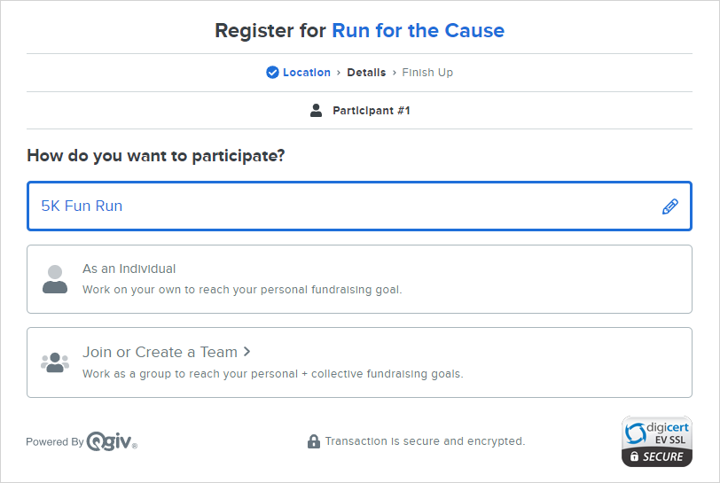

If you select **Join or Create a Team**, you’ll see a pop-up asking you to **Join** an existing team or **Start A New Team**.

[replace image with a screenshot of your Join a Team screen]

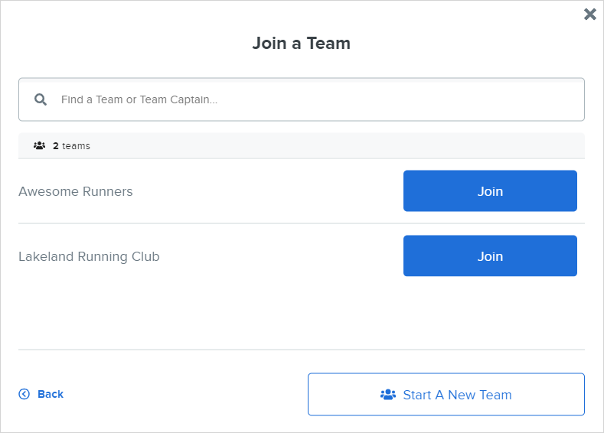

If you Start A New Team, you’ll choose the team's name and decide the team’s fundraising goal. You’ll also be designated as the team captain, which means you can edit the team’s fundraising page.

[replace image with a screenshot of your Start A New Team screen]

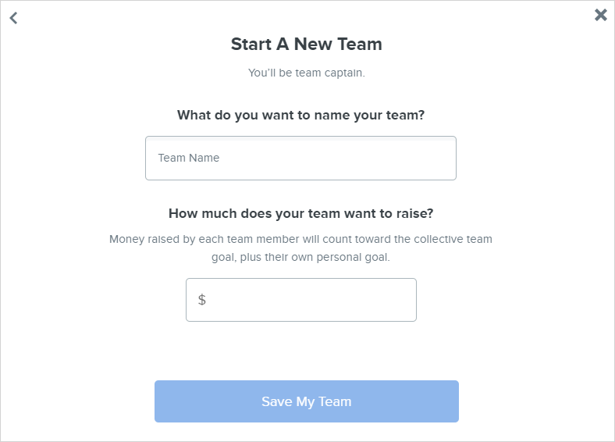

On the **Details** screen, you’ll determine your fundraising goal. If you’re part of a team, your personal goal will contribute to the team’s goal. [Remove the second sentence if you’ve disabled teams for the event.]

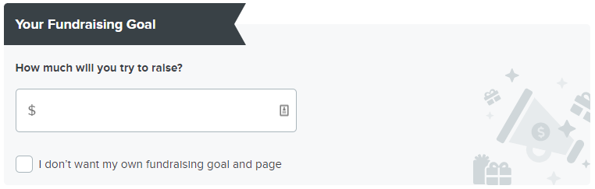

If you don’t want to have a fundraising goal and page, click the checkbox. This option is for registrants who want to participate in the event without fundraising. [If you’ve disabled non-fundraising participants, remove this section.]

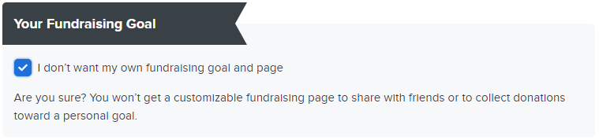

Then, fill in your personal information. If you’d like to **Add Another Participant**, you can do so now. [Remove previous sentence if you’ve disabled Additional Registrants.] Otherwise, click **Next**.

[replace image with a screenshot of your “Let’s get your details” screen]

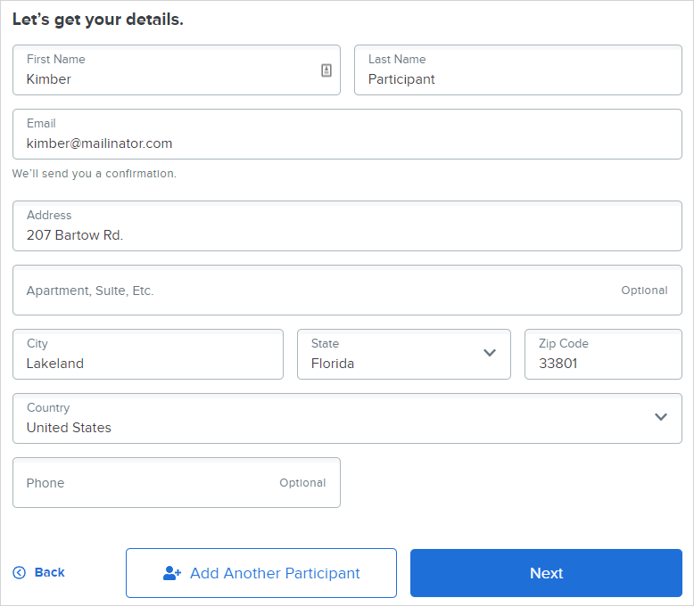

On the **Optional Add-ons** page [if you’ve changed the Store page heading, replace this with the wording you chose], you can select store items to purchase. [Remove this section if you have not enabled store items for purchase during registration.]

[replace image with screenshot of your Store page]

To add an item to your cart, click the item’s name, choose your quantity, and then click the **Add** button.

[replace image with screenshot of one of your item’s details]

Any items you add to your cart will appear on your registration summary. Click the **Next** button to proceed to checkout.

If you don’t wish to purchase any store items, just click the **Skip** button.

On the **Payment Details** screen, you can opt to include a donation. If you’re participating as a fundraiser, any optional gifts you make will count toward your fundraising goal. [Remove this section if you’ve disabled Optional Donations during registration.]

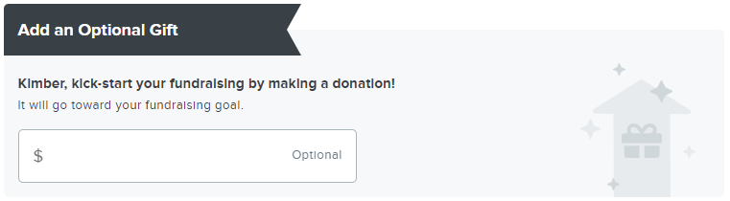

If you choose to add an optional gift, you can use the checkboxes to configure your anonymity settings.

[replace image with a screenshot of your Optional gift area]

Then, fill in your payment information.

[replace image with a screenshot of your Payment Details screen]

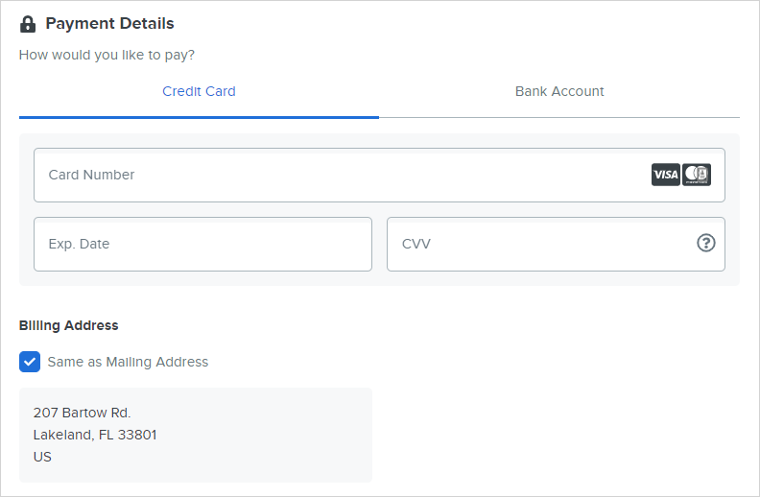

Before completing registration, you can review your registration summary on the right side of the screen. This is where you’ll apply any promo codes you have. [Remove previous sentence if you aren’t using promo codes.]

[replace image with a screenshot of your Summary area]

When you’re ready, click **Complete Registration**.

[replace image with a screenshot of your Complete Registration button]



On the registration confirmation screen, you’ll be asked to create an account if you’ve never participated in a peer-to-peer event powered by Qgiv.

[replace image with a screenshot of your Confirmation screen for a first-time registrant]

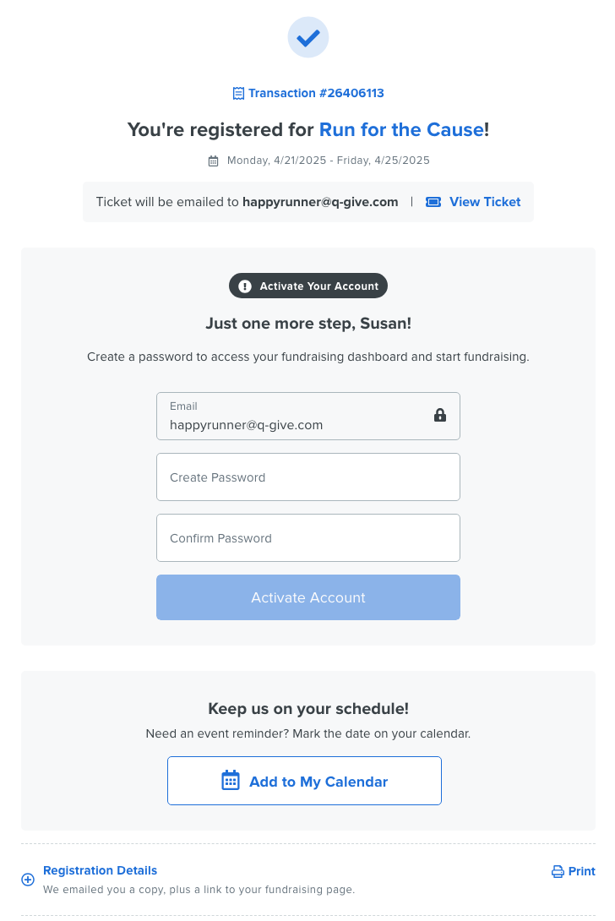

Click **My Fundraising Dashboard** to set up and manage your personal fundraising page.

[replace image with a screenshot of your Confirmation screen after an account is set up]

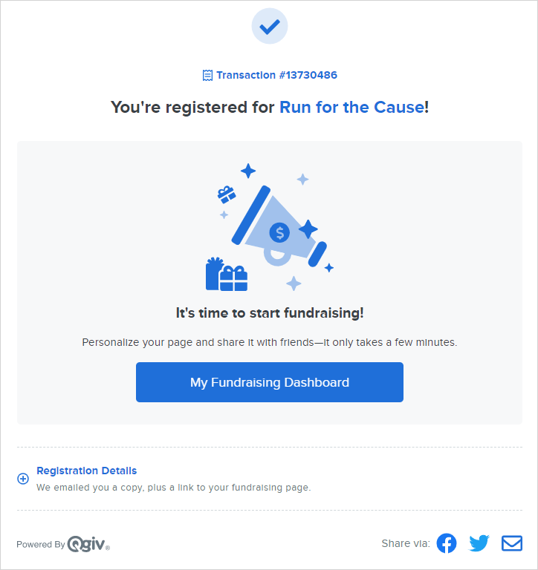

If you’ve participated in a peer-to-peer event powered by Qgiv in the past, you’ll be prompted to log in after you click My Fundraising Dashboard. If you don’t remember your password, click **I need help with my password**, and a reset link will be emailed to you.

[replace image with a screenshot of login screen for a returning registrant. If this is your first peer-to-peer event with Qgiv, you may not be able to generate this screenshot. Let us know if you need help.]

Thank you for registering for [enter name of your event]! Happy fundraising!