This editable Word document is designed to let you customize a guide to your text-to-donate campaign. **All notes in red should be replaced or deleted prior to sharing with constituents.** Feel free to remove any instructions that are not relevant to your campaign. For example, if you’ve disabled recurring gifts, simply remove that step of this guide.

We’ve also made recommendations for images you may want to replace with screenshots from your own donation form to match your campaign’s details and branding. If you prefer to use the images included in this document, simply delete the “[replace image]” notes.

**Text Giving How-To**

Thank you for your interest in supporting our text donation campaign! This guide will walk you through the process of making a donation by text.

1. To get started, send a text containing the keyword **[enter your keyword here]**, along with your donation amount, to the number **501-55**. Keywords aren’t case sensitive!

**Note:** If you don’t enter the amount you’d like to donate, you’ll receive a text message prompting you to enter an amount. [If you’ve disabled the “Require an amount” setting, replace this text with “**Note:** If you don’t enter the amount you’d like to donate, you can select an amount when you click the link to the donation form.”]

[replace image with a screenshot of your text-to-donate keyword in a text message]

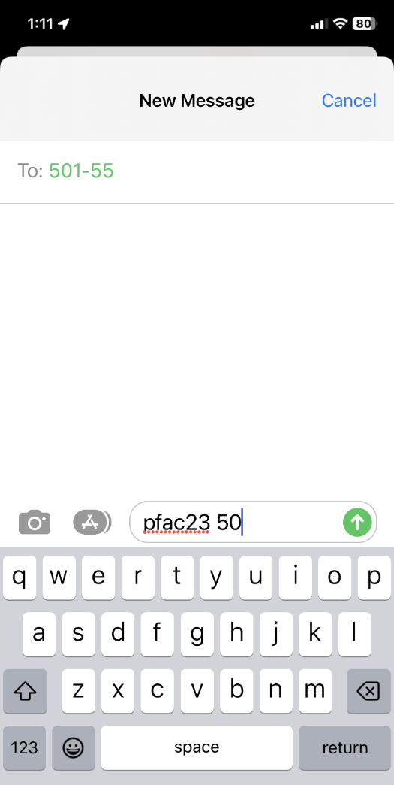

1. Once you’ve texted the keyword and entered an amount [delete red text if you’ve disabled the “Require an amount setting], you’ll receive a text response with a link to our donation form where you’ll complete your donation.

[replace image with a screenshot of your "Complete Your Gift” link in a text message]

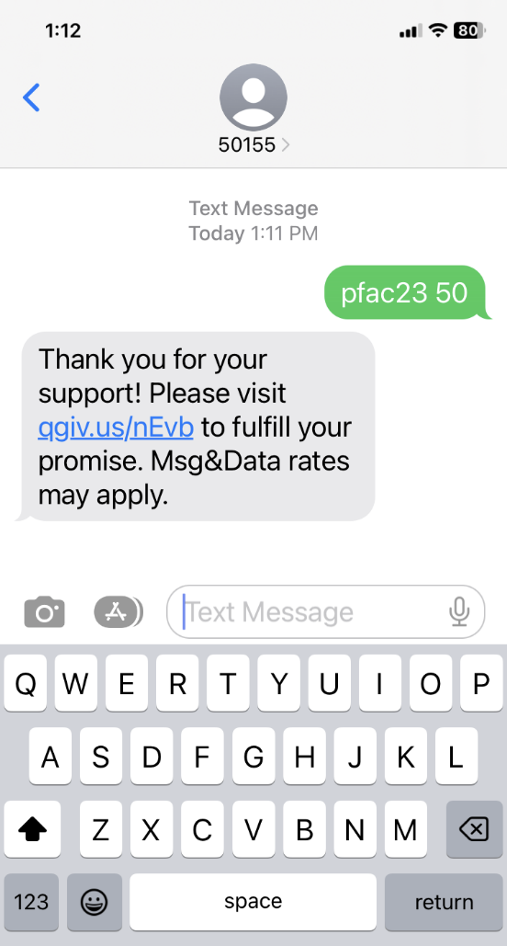

[replace image with a screenshot of your donation form’s "Complete Your Gift” step]

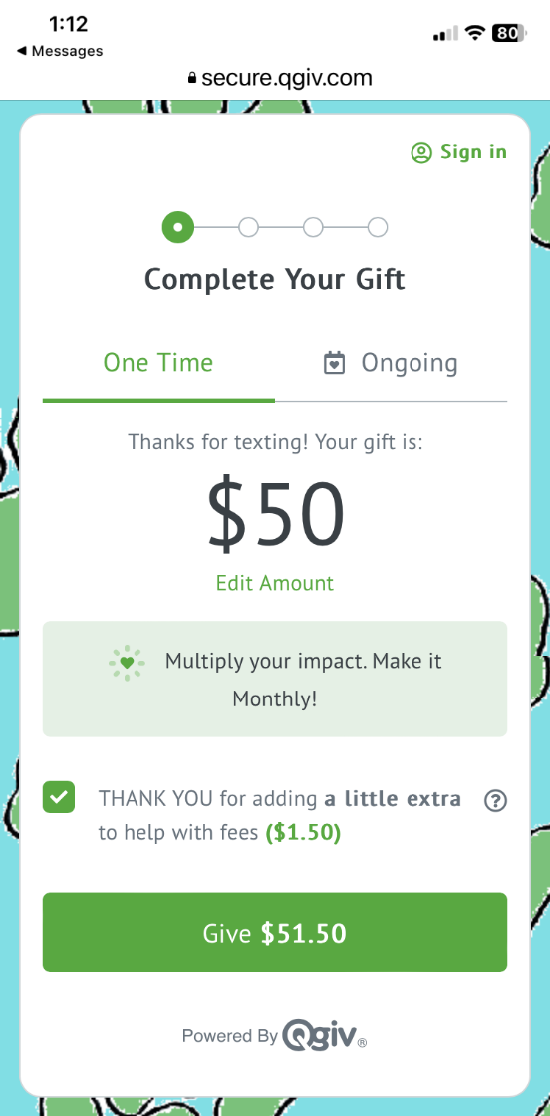

1. [Delete this step if not offering recurring gifts] If you’d like to make your gift ongoing (thank you!!), select the **Ongoing** [update the “Ongoing” language if you’ve customized your tab label] tab on the donation form.

[replace image with a screenshot of your donation form's Ongoing tab]

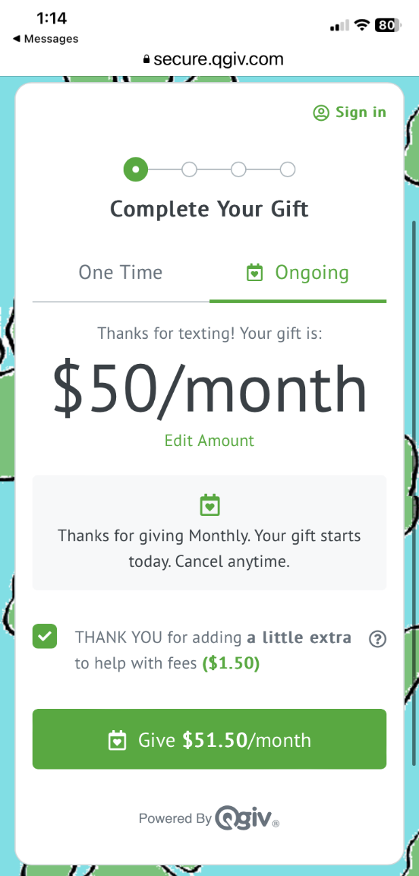

1. [Delete this step if not requesting additional information] Answer the questions on the **Additional Details** step.

[replace image with a screenshot of your donation form’s Additional Details step]

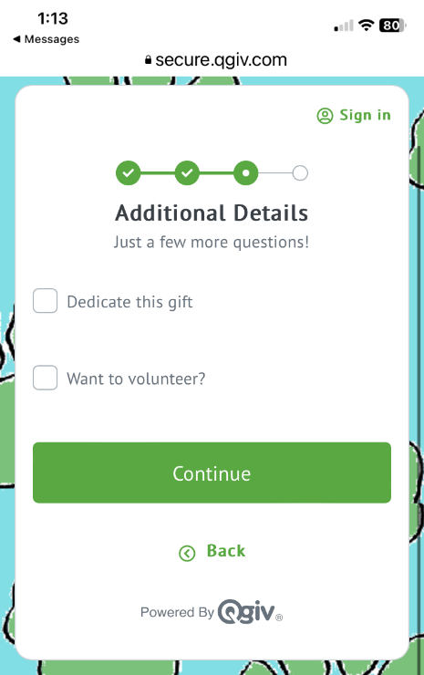

1. Choose if you’d like to pay with a credit card or eCheck, enter the required information, and tap the **Give** [update the “Give” text if you’ve customized your button label] button.

[replace image with a screenshot of your donation form’s Payment Details step]

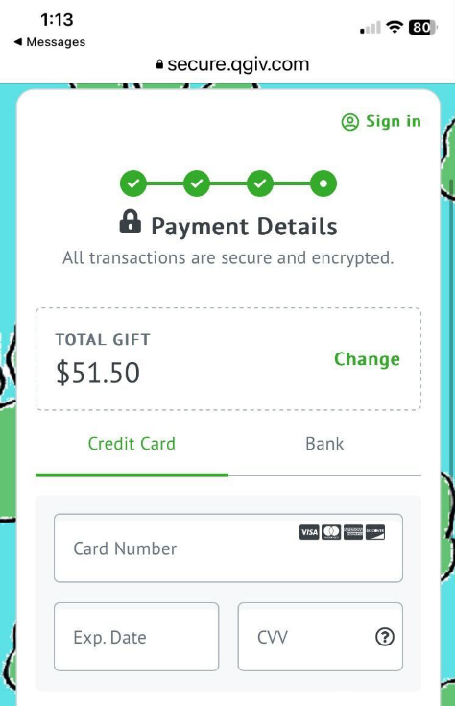

1. You’ll be taken to your receipt, which will also be emailed to you.

[replace image with a screenshot of your donation form’s Confirmation page]

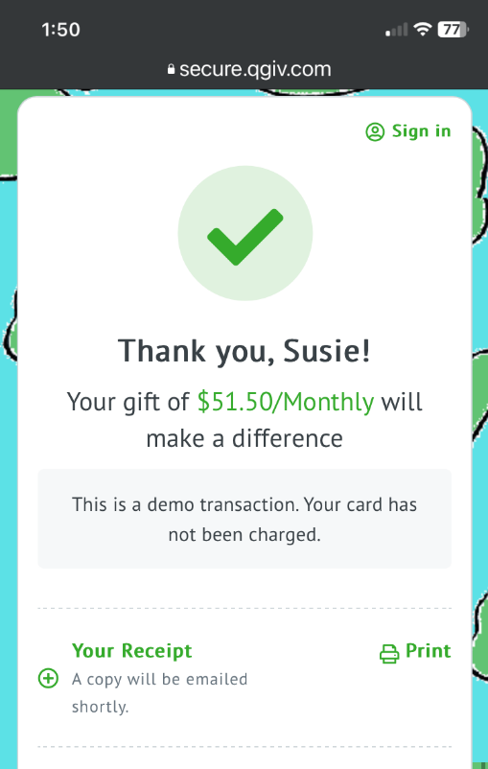

Thank you for your support! Your gift means so much to us!